Contract and Bill of Sale for Pet/Companion Dog/Puppy
A. Seller
DoodleDee Goldendoodles: Bethany Dills
Valparaiso, IN 46383 (219)805-9801

B. Transfer of Ownership to Buyer from Seller Buyers Name ___________________________________________________________________ Phone (________)___________________________ Date ________________________
Address: ______________________________________________________________________City______________________________State_____________Zip______________________
Email: ______________________________________________________ Driver’s License # (If paying by Check) _________________________________ State: ________

C. Litter/Parents
Breed ________________________ Dam of Litter: _______________________________ Sire of Litter: ____________________________ Litter DOB: ________________

D. Health Guarantee 1. Said puppy is sold as pet/companion only. Meaning not sold for breeding purposes unless stated otherwise within this contract. Failure to spay/neuter within a timely manner (Recommended to neuter between ages 8-12 Months Old/Spay between ages of 10-14 Months Old or after 1st Heat Cycle) will void all warranties offered. Breech of this agreement, intentional or accidental, will result in lawsuit filed against new owner for all compensation on income and fines for $20,000 PLUS all court costs/legal fees in seller’s jurisdiction. Said dog per contract will be surrendered and will become Seller’s Property Immediately. 2. Dog/Puppy will be free of any visual life threatening hereditary defects by the age of 12 Months Old. Defects to include only spinal, hips/patellas, thyroid, heart, and eyes. Pet to be replaced if returned to seller within 7 days of diagnosis from licensed veterinarian. Dog/Puppy will be replaced after said diagnosis is confirmed by seller’s licensed veterinarian. Transportation/Shipping for returning Dog/Puppy is solely buyers responsibility. No other warranty is given. Seller is not responsible for common issues. 3. A 7 Day Health Guarantee applies. Buyers must take Dog/Puppy to vet within 7 days of receipt or Health Guarantee is void.
4. If buyer must give up ownership of said Dog/Puppy, any time, no matter the age, he/she must be returned to seller at buyer’s expense, NO EXCEPTIONS unless otherwise agreed upon by Seller.

E. Spay/Neuter Agreement
We strive for the best in the breed and we breed for health and temperament for a loving family pet. Because of our strict guidelines we follow, we do not want an over population, nor any genetic defects bred irresponsibly in the breed, or inbreeding. Proper training should be given to maintain a great breed. Neutering also is proven to better a male’s nature by removing over aggressive hormones and prolong a healthier life of your male and female pet (ex, Cancers). There are recommendations on timing for this procedure. If females have Vaginosis/UTI issues it is important to spay after first heat. Males should be neutered by 8-12 months of age before aggression and territorial marking occur. Proof of Spay/Neuter is to be provided to Seller.

Buyer Signature _______________________________________________________ Date ____________________ Seller Signature _____________________________________

Purchase Price $_______________________ Minus Non-Refundable Deposit $_500.00__________ Balance DUE ______________________________ **Balance is DUE at Puppy Picking-Cash Only**
Puppy Purchased/Name ____________________________________________________
Choice # __________________________________________
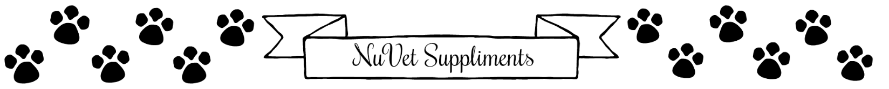

**HIGHLY Recommended**
If you plan on taking your dogs to the DOG PARK/Kenneling/Training Classes/Socializing with other dogs/pets, this product is an amazing IMMUNE Boosting supplement. It is FDA approved/Made in USA!
About NuVet Plus:
NuVet Plus is America’s premier pet immune system support supplement incorporating a precise formula of vitamins, minerals, enzymes, herbs an antioxidant that perform synergistically to bring together all of the vital ingredients required to maintain optimal health. NuVet Plus is made in the USA using natural, human grade ingredients that are formulated in an FDA registered pharmaceutical laboratory.
Veterinarian recommended, NuVet Plus was designed for dogs at every life stage; from supporting your puppy’s maturing immune system to helping to protect against issues later in life including, allergies, itching/scratching, hot spots, arthritis, digestive issues, tear staining, hair loss and more!
For your convenience you may order by calling 800-474-7044, MUST use order code 77573. NuVet products are not sold in stores. Customers outside the U.S. must place order by phone only.
TLC Pet Food
Highly Recommended to Keep the Puppy on the same food regime it started on to prevent Diarrhea and Upset stomach! TLC Pet Food is a very high-quality food which includes probiotics and is extremely healthy with LOW allergen ingredients! They use nutritionally beneficial whole grains and THREE premium meats as their main source of Protein including New Zealand Lamb, Farm fresh Chicken, and Non-GMO Atlantic Salmon. unlike many other companies that over compensate with plant-based proteins. Food is delivered FRESH and Delivered FREE!
https://www.tlcpetfood.com/104466-1025
TLC Pet Food- Order on TLCPetFood.com or Call (877)328-8400 *Dog/Puppy/Cat Food & Biscuits*
Tell them I sent You!
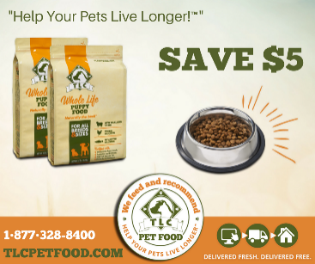

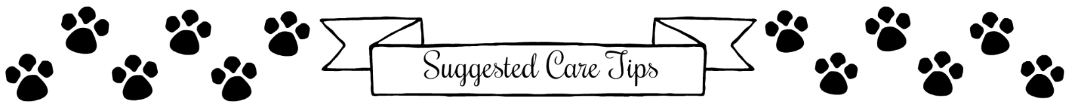
* Feed puppies 3 times a day until approx. 16 Wks Old, then 2 times a day/Use guideline on Puppy Food Bag (Do not feed/water after 6PM to prevent Accidents during night)
* Provide chew bones/toys to prevent puppy from chewing on harmful/personal items: This is very important! THROW small bones away to prevent choking/swallowing.
* Be persistent with potty-training: This can be a tough chore!! Reward good behavior (Doodles are a great candidate for Bell Training!) Puppies are on a 5AM/10PM schedule! TIP: Keep puppy in eyes view at all times! Place in crate for breaks!!
* For first few weeks, take puppy out on frequent potty breaks (Approx every 30 min) Keep puppy in close range/Do not allow puppy to wonder (May have an accident)
* Crate training is always recommended: Puppies will chew, have accidents, or get into harmful substances that can lead to harm or even death. Use a Divider to allow limited space to help with potty training (Do NOT line crate with paper!!) If placing towels/blankets in crate, monitor for chewing! May cause a bowel obstruction if ingested.
***Toxic to Pets: Gum, Chocolate, Avocados, Onions, Grapes/Raisins, Alcohol, Aspirin, Ibuprofen, Diet Pills, RX Drugs, Lawn Treatments, PLEASE RESEARCH HOUSE HOLD PLANTS-VERY TOXIC!!!!!***
* Groom puppy as needed/Do not dry skin out by giving too many baths (Use a recommended brand shampoo to prevent dry skin) Keep hind end trimmed to prevent feces sticking to surrounding fur. Keep ears cleaned/pluck inner ear hair. Clean Ears with each bath and weekly to prevent Yeast infections.
* Do not allow puppy to chew/bite. STOP them immediately!! Use Chew Deterrent Spray if problem persists
***Less stress can achieve a happy home!!***

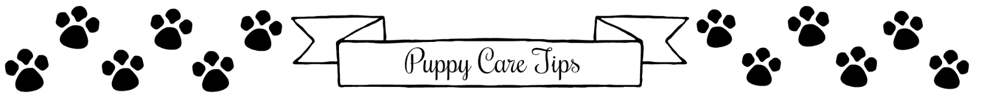
Fromm Puppy Food (Puppy Gold for small, Large Breed Puppy for Medium to Large)
NuVet Supplements (Supports Immune/Digestion System and MORE) MUST be ordered by Calling (800)474-7044 Must Use CODE 77573)
Storage Bin for Dry Food
Training Treats/Biscuits (Small Treats Work Best: Cheese/Hotdog Bits)
Do NOT over treat!! Can cause Diarrhea
Metal Crate with Divider (Size Pending Matured Height/Weight)
Old Towels/Blankets for Crate (Watch for chewing of towels!)
Metal Screw on Bowls for Crate (Prevents Spills!)
Baby Gate(s)/Play Pen (Limit Space to New Puppies) Keep on tile floor
Stain/Odor Neutralizer (White Distilled Vinegar Personal Favorite!)
Adjustable Nylon Collar with Clasp/Harness for Car Rides
0-14 Inch for Standard or Medium Doodle Puppies, 8-12 Inch for Mini

ID Tag (Pet Name & Phone Number)
Leash & Tie Out (Until Familiar with New Surroundings)
Toys: Balls/Kong Toys/Chew Bones/Raw Hides (Dispose of When Small)
Nail Clippers with Nail Guard & Blood Stop Powder (DO NOT Clip too Close)
Grooming Comb & Rake (Regular Grooming Recommended)
Small Hemostats (Removes Ear Hair-Infection will Occur if Hair Remains)
Medicated Ear Wash (Apply with Every Bath-Remove Gently with Washcloth) OR can use own recipe of ear wash- Half Cider Vinegar Half Rubbing Alcohol
Puppy Shampoo/Conditioner (Generic Not Recommended-Whitening for Light Colored Coats)
Toothbrush & Paste (Brush Teeth with Every Grooming-Greenies Between Recommended)
Bell for Bell Training- Hang by door designated for potty breaks (YouTube Videos for Bell Training a Puppy)

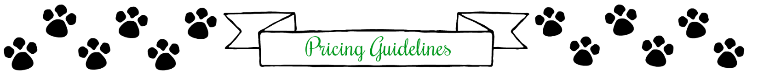
GOLDENDOODLES: ALL SOLID COLOR PUPPIES
Mini/Medium/Standard- $2,000.00
MicroMini/Petite’s- $2,500.00
Parti/Abstracts/Tuxedo or Special Colors- $300 EXTRA
Parti- 50% of body is white with another color
Abstracts- White Accent Markings (Paws/Chest/Head)
Special Colors- Sable, Phantom/Tri
Merle- $500 EXTRA

SHEEPADOODLES: BLACK/WHITE PUPPIES
Mini/Medium/Standard- $2,500.00
MicroMini/Petite’s- $2,800.00
Special Colors- $300 EXTRA
Special Colors- Chocolate, Phantom/Tri Color
Merle- $500 EXTRA

BERNEDOODLES: TRI COLOR/BI-BLACK COLOR PUPPIES
Mini/Medium/Standard- $3,200.00
MicroMini/Petite’s- $3,700.00
Merle $500 Extra

Please understand a puppy can start out appearing larger at first/ Or complete opposite!! Size is an estimate. Genetics can be very tricky!!!
If you choose to back out/pass, $500 Deposit is NONREFUNDABLE but is Transferrable to another litter of your choice!! Prices may vary pending size/color. We do master lists for sizes/breeds. Your deposit automatically rolls over until a perfect puppy is made for you!

